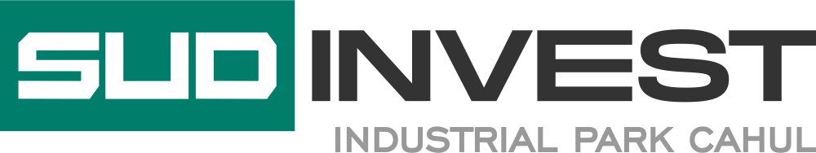
To: Sud-Invest Company Ltd
Cahul Industrial Park management company
Stefan cel Mare 102, mun. Cahul, MD-3905, Moldova
Susanu Dumitru, Administrator

To the attention of the Administrator
Establishing production activities in the SUDINVEST Industrial Parks.
LETTER OF INTENT
Hereby we express our interest to develop activities of production/services in
Industrial Park SUDINVEST.
For this purpose we send you the following preliminary information:

1 | Name of the company:
2 | City / address:
3 | Legal representative:
4 | Phone:
5 | E-mail:
6 | Web:
7 | Contact person:
8 | Profile of activity:
9 | Turnover (last 3 years):
10 | Other locations in RM/EU
11 | Number of employees:
12 | We'll start develop our acitivity in the Industrial Park SUDINVEST Cahul  from (trimester/month/year):
13 | Activity Description:
14 | Number of employees:
15 | The estimative value of the planned investment (EURO):
16 | Special/High technology processes: | Yes  No
17 | Describe the Special/High technology processes(if any):
18 | The necessary total area (square meters ):
19 | Area for constructions (Building /Production Hall) (square meters)
20 | - Network of water supply and sewage (c.m./month):
21 | - Network of natural gas supply (c.m./month):
22 | - Power supply (KW/month):
23 | -Other necessary services: | Public transport  Waste collection  Others (transport, construction, assembly, loading-unloading services, etc).
24 | OTHER INFORMATION THE APPLICANT CONSIDERS TO BE MENTIONED:

Name / Family _______________________________
Function ____________________________________
Authorized signature __________________________

Stamp

